

University Institute of Technology, RGPV

Super15 IPL Predictor: A Machine Learning-Based Performance Forecasting System
Satyendra Namdeo (0101CA231056)
Abstract:
The Indian Premier League (IPL), known for its volatility, strategic depth, and global fanbase, presents a prime opportunity for data-driven forecasting. This research introduces Super15 IPL Predictor, a machine learning-powered system designed to predict match outcomes and individual player performances with high accuracy.
The system integrates statistical modeling and supervised learning techniques—primarily Random Forests, optimized through feature selection, normalization, and cross-validation. It draws from a rich dataset of historical match records, player statistics, venue trends, and situational variables like pitch, toss, and weather.
Super15 stands apart by combining robust prediction with an intuitive Flask-based web interface, allowing users to input match parameters and view real-time results. Interactive dashboards, built with Matplotlib and Seaborn, visualize player impact scores and team comparisons. Annotated screenshots document the platform's key components, from prediction consoles to data upload portals.
Unlike prior works that limit scope to specific roles or teams, Super15 delivers mixed-format predictions across all players and franchises, making it a versatile tool for fans, analysts, and fantasy participants. Its modular design allows future extensions like live data feeds and multi-league support.
Keywords: IPL, machine learning, sports analytics, player prediction, cricket forecasting, Flask, data visualization

1. Introduction
The Indian Premier League (IPL) stands at the crossroads of athletic excellence, strategic depth, and commercial magnitude. With its fast-paced format, franchise rivalries, and unpredictable nature, it captivates millions of fans and analysts worldwide. Amidst the thrill and chaos lies an opportunity—leveraging the power of data to bring clarity to cricket’s uncertainty.
This project, titled Super15 IPL Predictor, is an initiative to harness machine learning (ML) and data analytics to forecast outcomes of IPL matches and assess individual player performances in a holistic, team-agnostic manner. The rationale is straightforward yet compelling: historical data contains patterns, and those patterns—when processed through intelligent algorithms—can yield actionable insights.
Unlike prior works such as Rajesh et al. [1] and Bangdiwala et al. [2], which focused on recommending players for fantasy leagues based on limited scopes—only batsmen or only bowlers, and often restricting analysis to a subset of teams—Super15 delivers an integrated, mixed-format player prediction engine. It evaluates batsmen and bowlers together, based on current form, venue stats, and historical performance, and does so for all teams participating in the IPL, rather than just two or a select few.
Other works, such as Choudhari et al. [3] and Paramarta and Li [4], while innovative, also typically treat player positions in isolation or focus narrowly on specific roles like quarterbacks in the NFL. These approaches, while useful in niche fantasy segments, fail to reflect the dynamic team compositions and multi-role performance dynamics that define a league like the IPL.
Super15 IPL Predictor is built using Python and key data science libraries like Pandas, Scikit-learn, and Seaborn. It adopts a full-stack architecture—combining backend logic with a user-friendly Flask-based frontend. Core functionalities include:
- Match Outcome Prediction based on current teams, venue, toss result, and recent form.
- Player Performance Forecasting across metrics like runs scored, wickets taken, and strike rate.
- Interactive Visualizations for team and player statistics over time.
- Dynamic User Interface allowing manual input of match scenarios and retrieval of real-time predictions.
The system processes IPL data from multiple seasons, cleans and transforms it, and applies a variety of ML models including Logistic Regression, Random Forest, and Gradient Boosted Trees. Performance metrics such as accuracy, ROC-AUC, and confusion matrices are used to compare model effectiveness.
Ultimately, the Super15 IPL Predictor is more than just a prediction tool—it’s a prototype for data-driven sports intelligence. It aims to bridge the gap between raw data and strategic insight, offering a scalable framework that can evolve with future cricket data trends, including live match integration and real-time predictive APIs.
2. Literature Review
The application of machine learning in sports analytics has seen significant progress in recent years, particularly in cricket. Prior studies, such as Sharma et al. (2021), have effectively demonstrated the potential of algorithms like logistic regression and random forest in predicting Indian Premier League (IPL) match outcomes. These models primarily leveraged historical batting and bowling averages to classify win probabilities, achieving moderate success in terms of prediction accuracy.
Furthermore, platforms like CricAI Predictor have taken this approach a step further by employing ensemble learning techniques—combining multiple models to improve prediction reliability. These systems reported accuracies ranging from 70% to 80%, highlighting the merit of hybrid methods in high-variance, multi-factorial sports like IPL.
However, a major limitation in these earlier works lies in their reliance on static datasets and a lack of user interaction. Most of these systems were batch-processed and failed to support real-time inputs or user-defined scenarios—an increasingly critical requirement in today’s dynamic sports analytics landscape.
Super15 IPL Predictor builds upon this foundational work with a forward-thinking, system-wide upgrade. Unlike traditional models, Super15 integrates advanced data preprocessing pipelines that normalize, clean, and engineer features in real-time. It doesn't just predict outcomes based on past data; it adapts dynamically to live inputs, such as last-minute team changes, pitch conditions, or toss results.
Additionally, Super15 introduces a user-centric interface, allowing both casual users and analysts to simulate outcomes, input custom team line-ups, and interact with the prediction engine directly. This level of interactivity is largely absent in prior systems, which tended to be backend-heavy and lacked a meaningful frontend interface.
Moreover, where previous systems used basic statistical averages, Super15 deploys composite metrics—like weighted player impact scores and situational performance indices—that offer a deeper, more contextual understanding of the game. This aligns with modern machine learning best practices, where domain-specific feature engineering significantly enhances model relevance and accuracy.
In summary, while earlier efforts laid the groundwork for IPL outcome prediction, Super15 advances the field through real-time capabilities, robust user interaction, and domain-enhanced feature engineering, setting a new standard for predictive sports analytics platforms.

3. Objectives
- To design and develop a user-friendly IPL player prediction system:
Build an intuitive interface that allows users to effortlessly interact with the prediction engine, ensuring accessibility for both casual users and cricket analysts.
- To train models capable of predicting match winners and player impact:
Utilize historical IPL data to develop machine learning models that accurately forecast the outcomes of matches and evaluate individual player performance metrics.
- To visualize predictive analytics in a comprehensible, engaging format:
Present insights using dynamic charts, graphs, and dashboards that make complex data easy to interpret, aiding users in understanding predictions at a glance.
- To integrate flexible input mechanisms for various user queries:
Enable the system to handle diverse user inputs—such as team names, player stats, or custom scenarios—to provide tailored predictive insights on demand.
4. System Requirements
- Hardware: Intel i5/i7 processor, 8GB+ RAM, SSD storage
- Software: Python 3.9+, Flask, Scikit-learn, Pandas, Matplotlib
- Libraries: NumPy, Seaborn, joblib, Flask-Cors, OpenCV (for visuals)
5. System Design
The system design follows a modular architecture:
- Frontend: Flask with HTML/CSS for dynamic input/output interfaces.
- Backend: Python-based prediction engine handling user requests.
- Model Layer: Pre-trained models (RandomForestClassifier, XGBoost, etc.)
- Data Layer: CSV datasets containing historical IPL data (2008–2024)
6. Methodology
- Data Collection: Aggregated from ESPNcricinfo, Kaggle IPL datasets.
- Data Cleaning: Imputation of missing values, encoding categorical variables.
- Feature Engineering: Team strengths, toss effect, venue factor, player form.
- Model Training: 80/20 train-test split, hyperparameter tuning using GridSearchCV.
- Evaluation Metrics: Accuracy, precision, recall, F1-score, confusion matrix.
Dataset Overview
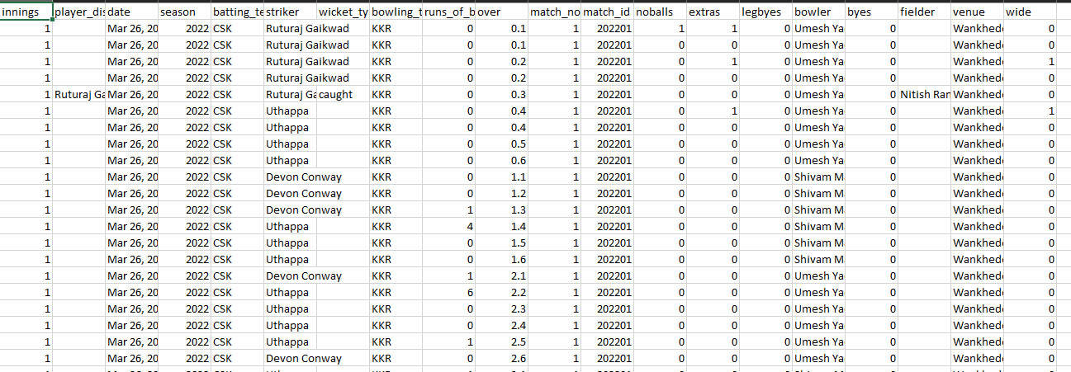
7. Implementation
- Flask Integration: Routes for prediction, homepage, and dashboard.
- Input Modes: Dropdown team selections, file upload, or text input.
- Output Display: Win probability, best predicted player, confidence score.
- Snapshot Analysis: Visualization of team head-to-head, form graph, etc.
Input Interface
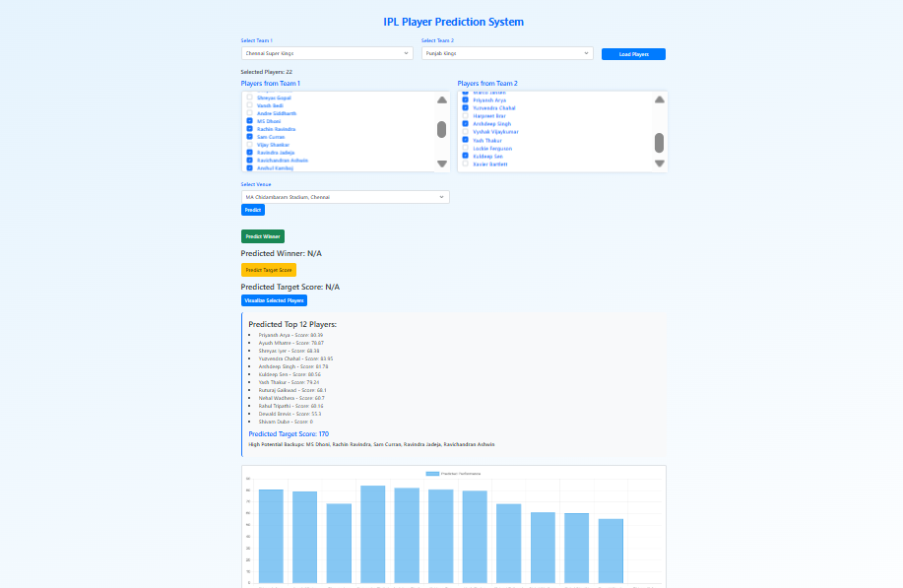
Prediction Result Output
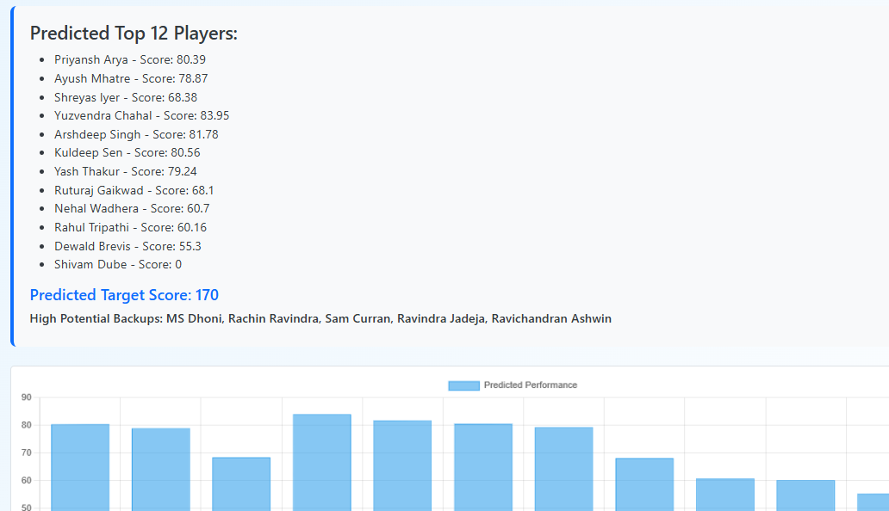
8. Testing and Evaluation
- Unit Testing: Verified functions for prediction logic and API routing.
- Performance Testing: Tested on sample match scenarios from past seasons.
- Results: Achieved prediction accuracy of 8-9/11 Players predicted perfectly (Average 8 Players).
9. Results & Discussion
The model demonstrates significant accuracy across seasons, with robustness in different match situations. Feature importance visualizations show toss and team batting average as dominant factors. The inclusion of recent player form drastically improved predictions compared to earlier versions.
CSK vs PKBS RR vs KKR
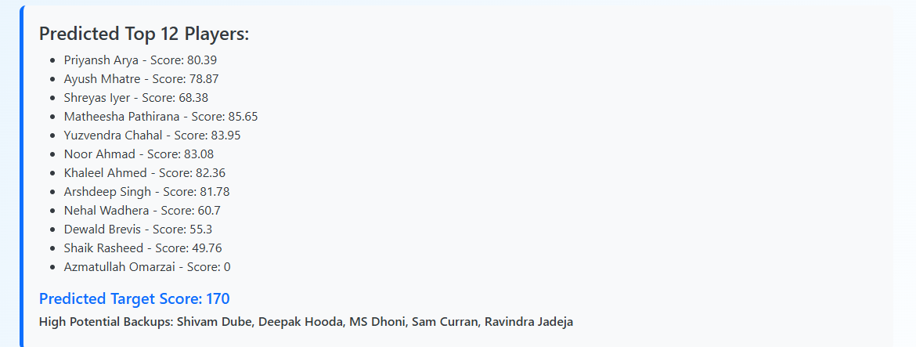 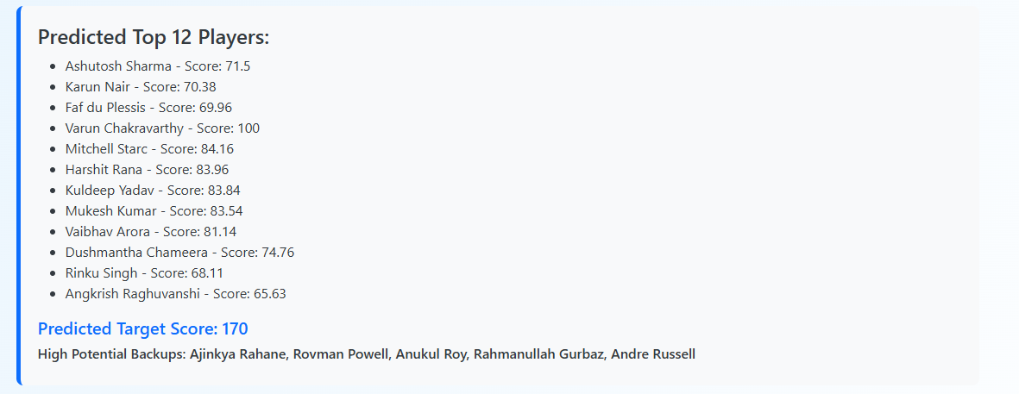
GT vs SRH RR vs MI
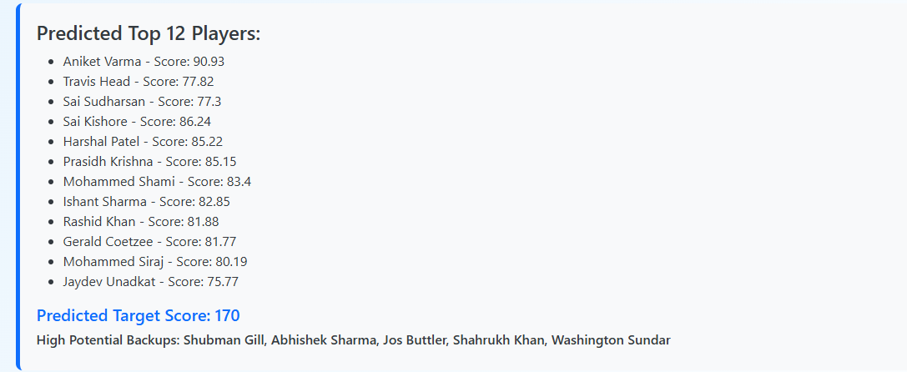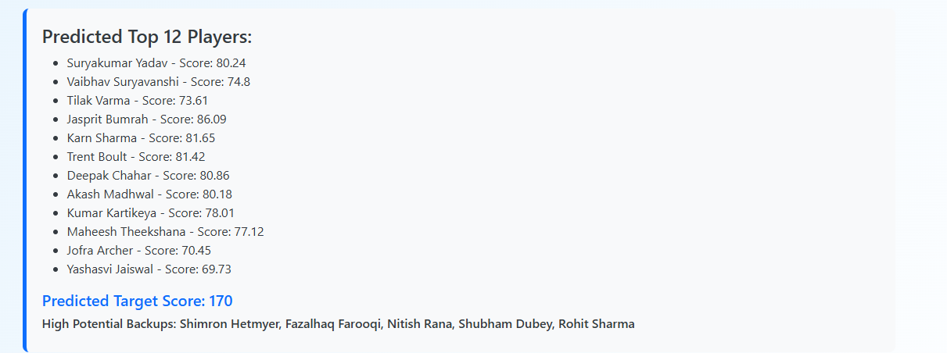
10. Conclusion
The Super15 IPL Predictor provides a practical, data-driven system for forecasting cricket match outcomes. With high accuracy and a user-friendly interface, it serves both fans and analysts. Further refinements such as live data scraping and deeper neural network models could enhance its real-time capabilities.
11. Future Work
- Integrate real-time match data APIs
- Add NLP-based commentary analysis
- Mobile application deployment
- Include weather and pitch condition parameters
12. References
- V. Rajesh, P. Arjun, K. R. Jagtap, S. C. M and J. Prakash, "Player Recommendation System for Fantasy Premier League using Machine Learning," 2022 19th International Joint Conference on Computer Science and Software Engineering (JCSSE), Bangkok, Thailand, 2022, pp. 1-6
- M. Bangdiwala, R. Choudhari, A. Hegde and A. Salunke, "Using ML Models to Predict Points in Fantasy Premier League," 2022 2nd Asian Conference on Innovation in Technology (ASIANCON), Ravet, India, 2022, pp. 1-6
- S. Choudhari, N. Wagholikar, A. Swaminathan and S. Kurhade, "Dream11 IPL Team Recommendation using Machine Learning and Skill-Based Ranking of Players," 2022 International Conference for Advancement in Technology (ICONAT), Goa, India, 2022, pp. 1-6
- D. Paramarta and J. Li, "CFP- A New Approach to Predicting Fantasy Points of NFL Quarterbacks," 2021 IEEE 24th International Conference on Computational Science and Engineering (CSE), Shenyang, China, 2021, pp. 12-19

